  شرکت نمایشگاه های بین المللی استان اصفهان | فرم دستور العمل نمایشگاهی  EXHIBITOR’S FORMS | شماره سند : ISF.IF.F08  تاریخ بازنگری : 15/05/1398  صفحه از

The 17th International Specialized Exhibition of Metallurgy, Steel, Foundry Machinery & Related Industries (METALEX 2025)
03 – 06 September 2025

Isfahan International Exhibition Center ( IIEC)
Isfahan, Iran

EXHIBITOR’S FORMS

FORM 1 – CATALOGUE ENTRY

Stand Number |  | Company Name
Mobile |  |  |  | Email
Contact Person
Designation
Website

Note: Information given above is what will appear in the official show catalogue.
Please mention products most relevant to your exhibit profile:

PRODUCT & SERVICES CATEGORY:

Company Logo: (Kindly insert your company logo here or send a separate file for your company logo in .jpg or .pdf format).

200-WORD COMPANY PROFILE: (English typed in MS Word)

FORM 2 – EXHIBITOR BADGES

Stand Number |  | Company Name
Mobile |  |  |  | Email

Application for exhibitor badges:
- Please type below the names of all your colleagues who will represent your company at the exhibition stand.
- All exhibitors must wear their badges with photo to gain entry into the exhibition hall.
- Badges will be ready for collection at the Information counter on site on the build-up day.

NAME | JOB TITLE | COMPANY

Kindly provide the above in typewritten form or block capitals (in MS Word Document Format) to ensure that the names are legible.
FORM 3- FASCIA NAME BOARD

Stand Number |  | Company Name
Mobile |  |  |  | Email

Shell Scheme Exhibitors’ Company Name and Stand Number appear on the STAND FASCIA NAME BOARD.

I wish the Company Name to appear as follows on the Stand Fascia:
(English)
(Please note that the name should be typewritten or printed in block capitals, with a maximum of 30 characters)

FORM 4 - SHELL SCHEME SPECIFICATIONS

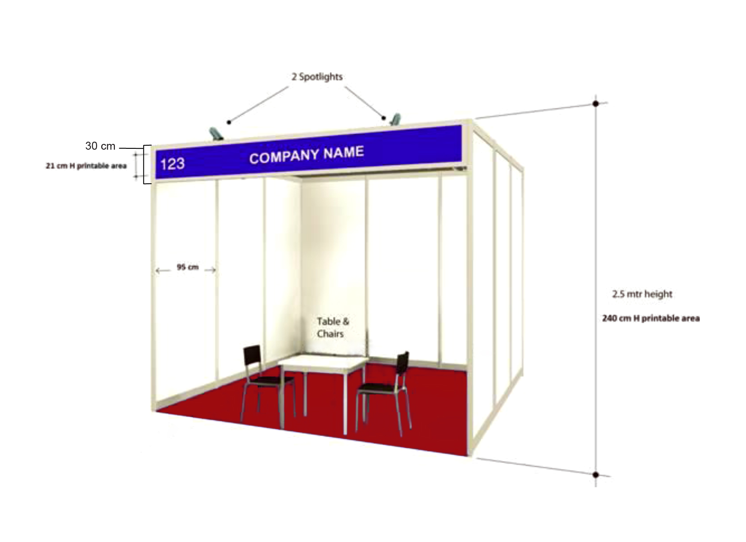

The shell scheme stand consists of a basic stand shell construction suitable for customizing to your individual requirements, in a wide variety of sizes, with rear dividing walls.

*Please note that the above image is only for visual purposes wall panels will vary depending on your location.

Rear & Dividing Walls | 2.5 meters high comprising x 1meter wide panels; white plastic finish set in aluminum frame. No fixing may be made to the walls.
Fascia | Fascia board bearing the company name English & stand number.  30cm x 297 cm ( for 3*3 stand) and 30cm*397cm ( for 3*4 stand)
Flooring | Epoxy
Lighting | 2 spotlights & 1(13amp) electrical socket. Per 12 Sq m
Furniture | 1 Table, 2 Chairs, Waste Basket
- All exhibits and display materials must be within the stand area.
- Corner stands will have only two walls constructed, e.g., two sides open.
- Exhibitors may affix lightweight photos, technical information, sheets, etc., directly on the shell scheme walls with double sided adhesive tapes or similar materials, provided such materials can be removed at the close of the exhibition without damage to wall panels.
- Exhibitors occupying shell scheme stands must ensure that all internal stand fittings, exhibits and displays are within the shell scheme structure and so not to exceed 2.4m in height, or 1 meter in height with 50cm from the front of the stand.

FORM 5- Exhibition Timetable

Build - Up
01 September 2025 | 08:00 – 20:00 | Shell Scheme moving in
02 September 2025 | 08:00 – 20:00 | Dressing & Completing of all stands

Please note:

- All movement of exhibits and materials should be completed before 20:00 on
02 September 2025.

- Only decoration/finishing will be permitted on 03 September 2025, from 7:00a.m. - 14:00 p.m.

- Exhibitor Badges must be collected from the registration counter on 03 September.

Event Hours
03 September | 16:00 – 17:00 | Opening Ceremony / Inauguration  VIPs & Selected Invitees
03 September | 16:00 – 22:00 | Professionals & Trade Visitors
04 September | 16:00 – 22:00 | Professionals & Trade Visitors
05 September | 16:00 – 22:00 | Professionals & Trade Visitors
06 September | 16:00 – 22:00 | Professionals & Trade Visitors

Breakdown
07 September | 22:00 – 23:30 | Removing of Exhibits  (Make sure that no valuables are left in the Exhibition Center)
08 September | 08:00 – 20:00 | Dismantling of Stands
Please note:

- Never leave your exhibit unmanned at any time during the move-out.
- The organizers will not be responsible for any goods left on site after the dismantling period.

